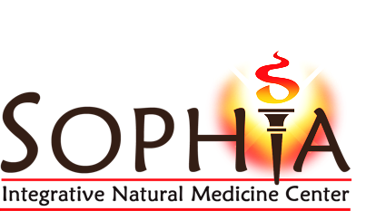
Applications
• Improves Stress Resilience
• Supports Healthy Energy Levels
• Strengthens the Body’s Stress Response
• Improves Mental and Physical Performance
• Helps Maintain a Balanced Cortisol-to-DHEA Ratio

AdrenaBoost V contains a blend of key micronutrients and adaptogenic botanicals specifically formulated to strengthen the body’s stress response and support healthy energy levels. AdrenaBoost V provides targeted amounts of vitamin C, pantothenic acid and other B vitamins that are critical to adrenal gland function. AdrenaBoost V also provides a unique blend of “stress adapting botanicals” which help increase the body’s resistance to fatigue and maintain balanced cortisol and DHEA levels.

Overview
Stress is defined as any disturbance –extreme cold or heat, psychological stress, sleep deprivation, work overload, physical trauma, as well as toxic exposure– that can trigger the stress response. The body’s stress response system is comprised of the hypothalamic-pituitary-adrenal (HPA) axis. Prolonged stress triggers the HPA axis and consists of three stages: stage 1: alarm; stage 2: resistance; and stage 3: exhaustion.

The initial, short-lived phase (the alarm phase) is the body’s normal fight-or flight response to danger which is characterized by elevated cortisol levels. The next phase, the resistance phase, allows the body to continue buffering extended stress exposure, long after the initial fight-or-flight response has dissipated. Hormones released by the adrenals, such as cortisol and DHEA, help support the “resistance” reaction. However, extended periods of stress not only burden the system, creating an imbalance in cortisol and DHEA production, but can result in mental and physical fatigue, nervous tension, irritability and poor memory- all of which are characteristic of stage 3. AdrenaBoost V provides a unique blend of botanicals and micronutrients that

support the adrenal glands as well as the body’s ability to respond to and counteract the negative effects of stress.

Rhodiola rosea Root Extract†
Rhodiola rosea has been categorized as an adaptogenic botanical due to its ability to increase resistance to a variety of stressors.¹ Rhodiola has been studied extensively and is widely used in Eastern Europe and Asia to help support the nervous system, mood regulation, mental clarity, work performance and the sleep cycle.¹ Within the central nervous system, Rhodiola has demonstrated an ability to preserve levels of neurotransmitters such as serotonin, dopamine and norepinephrine. In a randomized, double-blind placebo controlled study examining the effects of Rhodiola on fatigue and stress, 161 patients aged 19 to 21 years received 185 mg of Rhodiola twice daily and saw a significant reduction in fatigue.² An additional study using Rhodiola extract in students showed significant improvements in mental performance, greater mood stability and improved sleep patterns.³

Eleuthero Root Extract†
Eleutherococcus senticosus has been identified as a strong adaptogenic botanical and is widely used in China to improve general health, support memory and physical endurance.⁴ In addition to its ability to improve stress resilience and maintain energy, Eleuthero has been shown to support the immune system.⁵ In a double -blind study, the adaptogenic effects of Eleuthero were demonstrated to help maintain a sense of calmness, reflected by a reduction of heart rate, during stress exposure.⁶ Eleuthero has also been shown to improve performance in runners. In a study on performance athletes, Eleuthero extract (2 or 4 mL) given 30 minutes

ENDOCRINE HEALTH

†These statements have not been evaluated by the Food and Drug Administration. Originally from Ortho Molecular Products Adapten-All.
This product is not intended to diagnose, treat, cure or prevent any disease. Adapted by SOPHIA Natural Health Center.
AdrenaBoost V

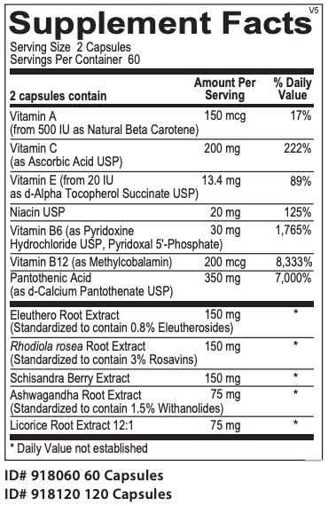
prior to a race significantly reduced race time (48.7 minutes) compared to the control group (52.6 minutes).⁷

Schisandra Berry Extract†
Schisandra is an adaptogenic botanical that has been used for centuries in China and Russia to help support mental clarity, stress response and emotional wellness. In a double-blind, placebo-controlled study, athletes were given Schisandra chinensis and Bryonia alba extracts or placebo. Those receiving the therapy had increased concentrations of nitric oxide, a molecule which causes the blood vessels to expand resulting in increased circulation, increased blood flow and nutrients throughout the body.⁸ The researchers concluded that Schisandra provides supportive factors for physical performance in athletes.⁸ Schisandra berry has been shown to support learning and memory and may have some protective factors that support brain health.⁹

Licorice Root Extract†
The primary components in licorice root that support adrenal health include glycyrrhetic acid and glycyrrhizin. Licorice has also been shown to block 11-β-hydroxysteroid dehydrogenase, the enzyme responsible for the conversion of cortisol to the inactive cortisone. When taken in small doses, licorice root extract can be used to maintain normal cortisol levels, an important factor for individuals that need to support adrenal hormone production and maintain healthy inflammatory pathways.¹⁰

Ashwagandha Root Extract†
Ashwagandha’s strong adaptogenic properties provide an array of benefits for individuals that have compromised health due to extreme stress exposure. Ashwagandha’s benefits include improving stress resilience, supporting immune response, regulating the sleep cycle, supporting healthy thyroid function and protecting against exhaustion of the nervous system.^{11,12} Ashwagandha has also been shown to be beneficial in supporting proper mood regulation and restoring a sense of calmness under stress.¹²

Micronutrient Blend†
AdrenaBoost V contains a combination of micronutrients that are crucial for buffering the effects of stress and supporting adrenal gland function.

Pantothenic acid (vitamin B5) helps support adrenal gland function.¹³ Pantothenic acid also breaks down in the body into coenzyme A, which plays a large part in energy (ATP) production. Vitamin B6 is a required cofactor for the synthesis of several neurotransmitters that help buffer stress including serotonin, GABA and dopamine. Vitamin B12 (methylcobalamin) helps to reset the circadian rhythm of cortisol excretion throughout the day.¹⁴ Vitamin C is a vital nutrient for adrenal gland function- vitamin C levels are among the highest in the adrenal glands compared to other organs and urinary excretion of vitamin C is elevated during times of stress. Supplementation with vitamin C supports the health of the adrenal glands and immune function.

Directions
2 capsules one or two times per day or as recommended by your health care professional.

Does Not Contain
Wheat, gluten, corn, soy, animal or dairy products, fish, shellfish, peanuts, tree nuts, egg, artificial colors, artificial sweeteners or preservatives.

Caution
Do not consume this product if you are pregnant or nursing.

†These statements have not been evaluated by the Food and Drug Administration. This product is not intended to diagnose, treat, cure or prevent any disease.
SOPHIA Natural Health Center, 31 Old Rt. 7, Brookfield, CT
Phone: (203) 740-9300 || Web: inm.center

References
- Rhodiola rosea. Altern Med Review 2002;7 (5):421-423.

- Shevtsov, VA, Zholus BI, et al. A randomized trial of two different doses of a SHR-5 Rhodiola rosea extract versus placebo and control of capacity for mental work. Phytomedicine 2003; 10(2-3):95-105.

- Spasov AA, Wikman GK, Mandrikov, et al. A double blind, placebo controlled pilot study of the stimulating and adaptogenic effect of Rhodiola rosea SHR-5 extract on the fatigue of students caused by stress during an examination period with a repeated low-dose regimen. Phytomedicine 2000;7:85-89.

- American Botanical Council. American Botanical Council. Eleuthero root. http://www.herbalgram.org. 2002.

- Eleutherococcus senticosus. Altern Med Review 2006;(11):2.

- Facchinetti F, Neri I, Tarabusi M. Eleutherococcus senticosus reduces cardiovascular response in healthy subjects: a randomized, placebo-controlled trial. Stress Health 2002; 18:11-17.

- Halstead BW, Hood LL. Eleutherococcus senticosus /Siberian ginseng: An introduction to the Concept of Adaptogenic Medicine. Long Beach, CA: Oriental Healing Arts Institute; 1984:28.

- Panossian, AG, Oganessian AS, et al. Effects of heavy physical exercise and adaptogens on nitric oxide content in human saliva. Phytomedicine. 1999; 6(1):17-26.

- Kang SY, Lee KY, et al. ESP-102, a standardized combined extract of Angelica gigas, Saururus chinensis and Schizandra chinensis, significantly improved scopolamine-induced memory impairment in mice. Life Sci 2005; 76(15):1691-1705.

- Guilliams TG, Edwards L. Chronic Stress and the HPA Axis. The Standard 2010;9(2).

- Mishra, LC, Singh BB, Dagenais S. Scientific basis for the therapeutic use of Withania somnifera (ashwagandha): a review. Altern Med Rev 2000; 5(4):334-346.

- Withania somnifera. Monograph. Altern Med Review 2004;9(2):211-214.

- Onuki M, Suzawa A. Effect of pantethine on the function of the adrenal cortex. 2. Clinical experience using panthethine in cases under steroid hormone treatment. Horumon To Rinsho 1966;14:843-847.

- Tomoda A, Miike T, Matsukura M. Circadian rhythm abnormalities in adrenoleukodystrophy and methyl B12 treatment. Brain Dev 1995;17: 428-431.

