Newtown VNA Presents:

“Matters of the Heart: An Integrative Approach to Cardiovascular Disease”

According to John Hopkins School of Medicine, Cardiovascular Disease (CVD) is the cause of more deaths than cancer, respiratory diseases and accidents combined. The latest data states that more than 1/3 of all these deaths can be prevented.
In this brief lecture, Dr. Kenneth Hoffman, DACM, Medical Director of SOPHIA Natural Health Center in Brookfield, will introduce innovative information to detect early risk factors of CVD including tests and treatment that can successfully prevent CVD, naturally. This is information that every person should know if they want to live a long, healthy life!

Tuesday, February 5th, 2019
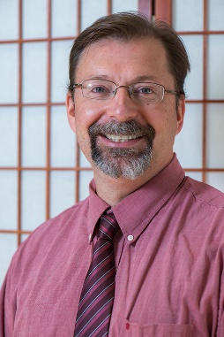
When: 9:30 am – 10:00 am
Where: Newtown Municipal Center, Council Chamber, 3 Primrose St., Newtown, CT
Cost: FREE
Dr. Kenneth Hoffman, DACM, L.Ac., CCH, is the Medical Director for SOPHIA Natural Health Center located in Brookfield, CT. It is one of the busiest holistic clinics on the East Coast. He is co-author of the book “Essential Remedies for Women’s Health” and host of the radio talk show “The Natural Medicine Connection” on 800/94.1 WLAD every Saturday, from 10 to 12 p.m.
SOPHIA Natural Health Center is located at: 31 Old Route 7, Brookfield, CT 06804
(203) 740-9300 Web: inm.center

